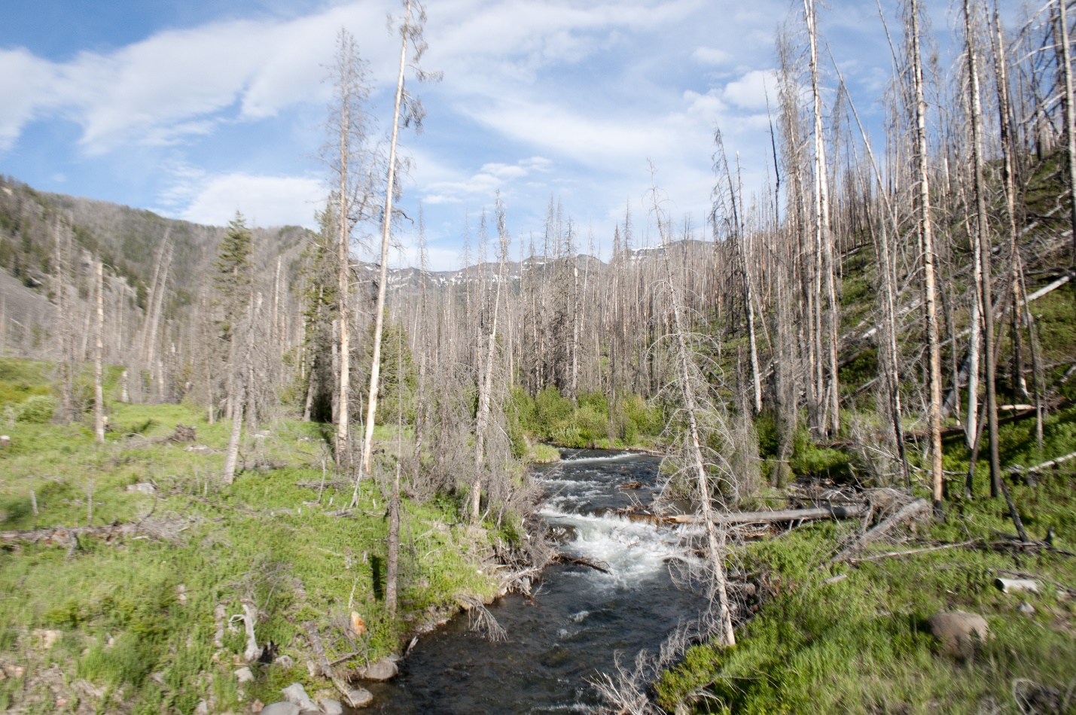
Upper Mill Creek. Photo by George Wuerthner.
NAME: PASSAGE CREEK—UPPER MILL CREEK ADDITION TO AB WILDERNESS
SIZE: 2,536 acres.
ELEVATION: Minimum Elevation 6,649 ft. Maximum Elevation 9,187 ft.
LOCATION: 30 miles south of Livingston.
FS POLYGON AB 83
ATTRIBUTES: The Passage Creek—Upper Mill Creek proposed addition to the AB Wilderness lies at the upper end and south of the Mill Creek road. The roads in Mill Creek create the boundary for this area, but it is immediately adjacent to the AB Wilderness with two trails crossing it—Cooley Creek and Lambert Creek. This area is a popular hunting area, especially during goat season in the Lambert Creek/Crow Mountain area. Much of this area burned in recent fires and is quickly growing back with a great deal of shrubs that provides good habitat for elk, mule deer and other wildlife.
PLANT COMMUNITIES: 60% transitional forest, 20% Douglas fir, and 15% lodgepole pine. Some 1,096 acres burned in 2006 and another 995 acres in 2007.
WILDLIFE: Mountain goat, grizzly bear, black bear, elk, mule deer, whitetail deer and moose. Yellowstone Cutthroat Trout known to occur within 2 miles of stream.
DRAINAGES WITHIN PROPOSED WILDERNESS: Upper Mill Creek, Passage Creek.
