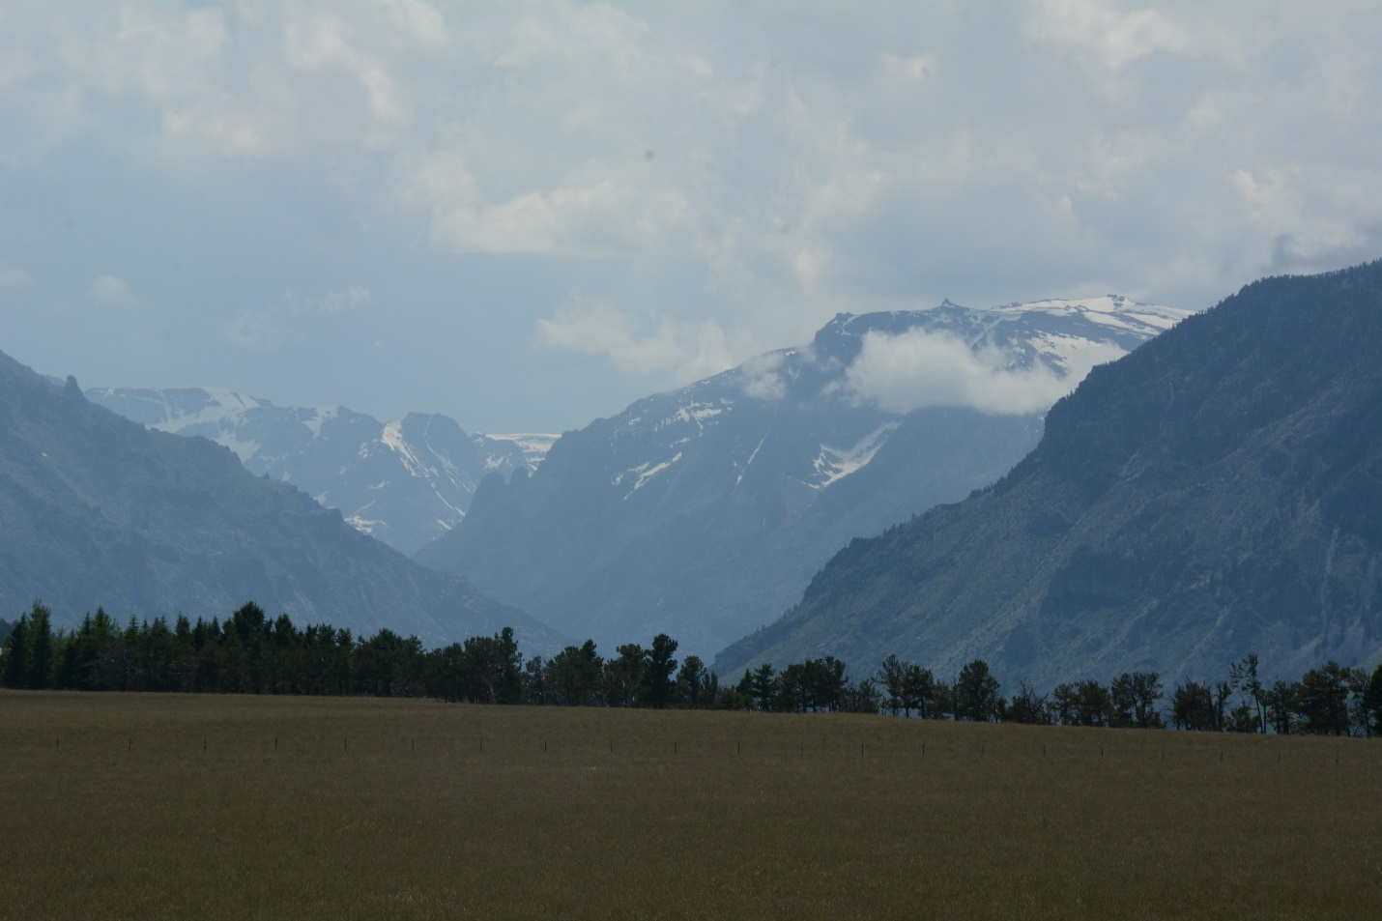
Looking up Stillwater Valley in Beartooth Mts. Photo by George Wuerthner.
NAME: Upper Stillwater West
SIZE: 4,323 acres
ELEVATION: Minimum Elevation 6,002 ft. Maximum Elevation 8,846 ft.
LOCATION: South of Columbus along Stillwater River.
FS POLGON AB 74
ATTRIBUTES: The Upper Stillwater West area is included because It is adjacent to the Absaroka-Beartooth Wilderness. One problem, however, is that the area is almost bisected by private lands. The West fork Stillwater River Road #2846 is adjacent. The Rabbit Gulch Trail #20, that bisects the area from north to south.
PLANT COMMUNITIES: 90% lodgepole pine with 10% Douglas fir.
WILDLIFE: Elk, mule deer, black bear.
DRAINAGES IN THE PROPOSED WILDERNESS: Mountainview Creek, West Fork Stillwater.
