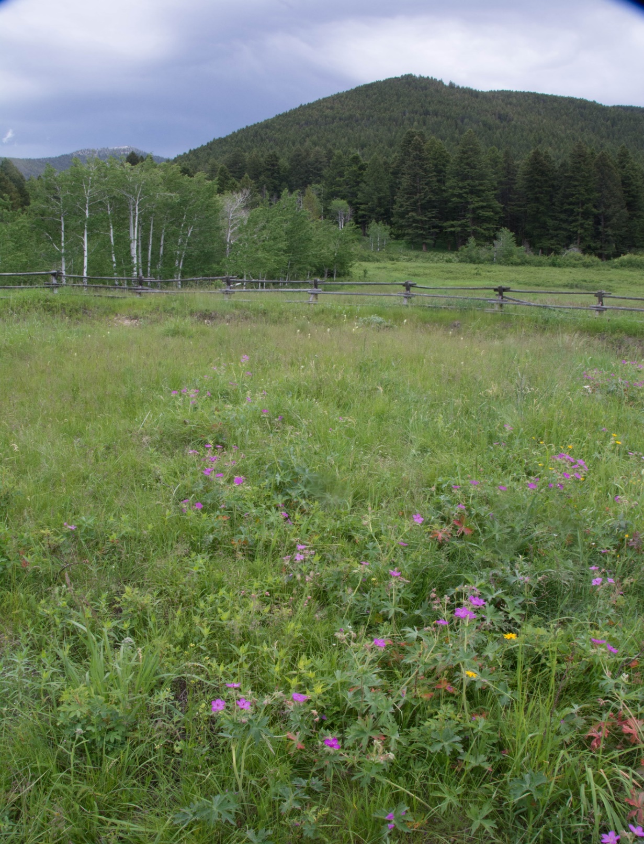
By Suce Creek Trailhead. Photo by George Wuerthner.

NAME: SUCE CREEK ADDITION TO AB WILDERNESS
SIZE: 349 acres
ELEVATION: Minimum Elevation 5,386 ft. Maximum Elevation 6,488 ft.
LOCATION: South of Livingston and up Suce Creek
FS POLYGON AB 79
ATTRIBUTES: This is the Suce Creek Trailhead area with access to Livingston Peak. There is currently a hiking trail and mountain biking trail in this area. The mountain biking trail could be moved to the forest boundary where there is already an illegal mt biking trail and allow most of this unit to be designated wilderness. The area is an important winter area for elk, whitetail deer, moose and mule deer.
PLANT COMMUNITIES: Aspen, Douglas fir, Lodgepole Pine.
WILDLIFE: Moose, elk, whitetail deer, mule deer. Yellowstone Cutthroat Trout known to occur within 1 mile of stream.
DRAINAGES IN THE PROPOSED WILDERNESS: Suce Creek.
