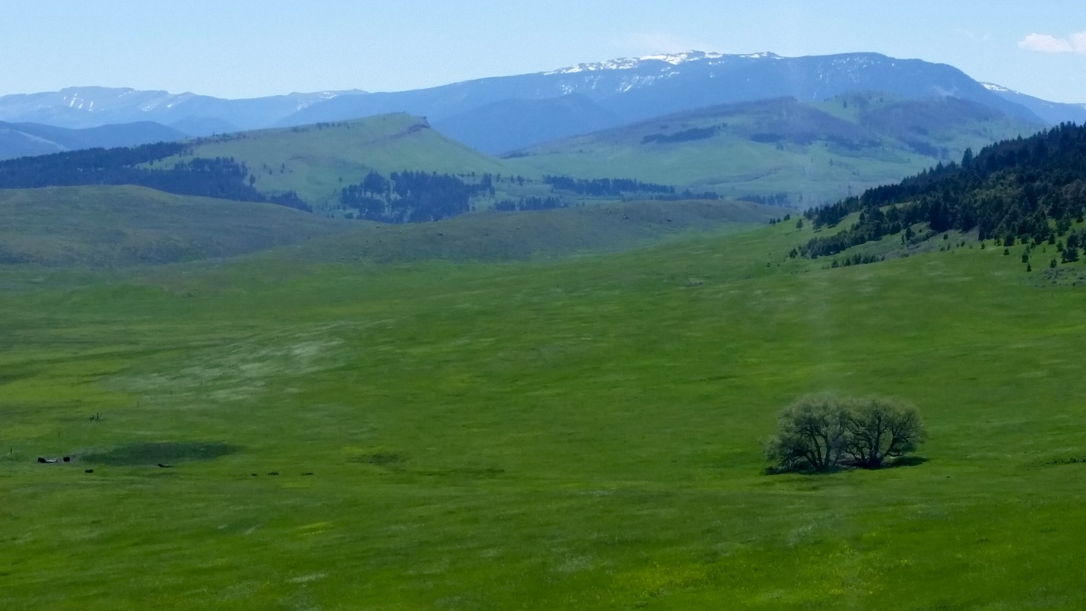
Looking to Mount Rae and West Boulder River valley. Photo by George Wuerthner.
NAME: WEST BOULDER—MOUNT RAE ADDITION TO ABSAROKA BEARTOOTH WILERNESS
SIZE: 5,375 acres
ELEVATION: Minimum Elevation 5,136 ft. Maximum Elevation 9,187 ft.
LOCATION: South of Big Timber, Montana.
FS POLYGON AB 26
ATTRIBUTES: The West Boulder-Mount Rae addition to the AB Wilderness lies on the north face of the mountains between the Main Boulder and West Boulder drainages. There are some open grassy parks mixed with aspen. Mount Rae is a high point on the border of the AB Wilderness.
PLANT COMMUNITIES: Some aspen, 30% Douglas fir, and 15% dry grass.
WILDLIFE: elk, moose, mule deer, whitetail deer.
DRAINAGES IN PROPOSED WILDERNESS: West Boulder River, Fall Creek.
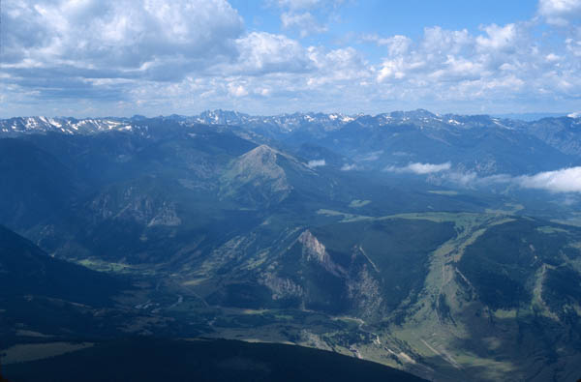
Looking across Boulder River towards Mt. Rae. Photo by George Wuerthner
