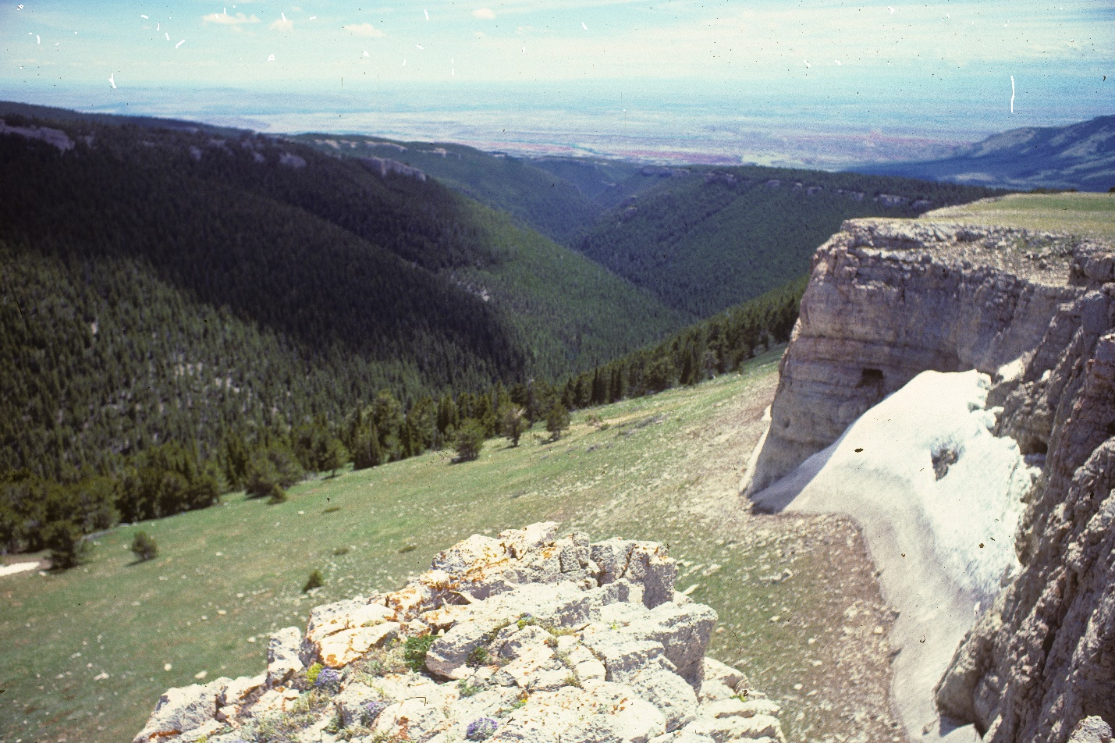
Lost Water Canyon in Pryor Mountains. Photo by George Wuerthner
NAME: Pryor Mountains—Lost Water Canyon
SIZE: 13,547 acres
LOCATION: East of Bridger, Montana.
ELEVATION: Minimum Elevation 4,972 ft. Maximum Elevation 8,715 ft.
FS POLYGON: Pryor 1
ATTRIBUTES: The Lost Water Canyon area consists of subalpine meadows and subalpine fir at higher elevations with Douglas fir and dry shrub lands/grasslands at lower elevations. The highly scenic area is dissected by the deep rugged limestone canyons including Crooked Creek, Commissary Creek, Cave Creek and Lost Water Creek. The area contains 3,159 acres of Wild horse range, established pursuant to the 1971 Wild and Free-Roaming Horses and Burros Act.
Unique characteristics include caves and scenic canyons found within portions of the area that overlaps with the Lost Water Canyon Research Natural Area (approx. 2,800 acres). Portions of this area (totaling 6,800 acres) were previously recommended as Wilderness in the 1986 Custer Forest plan.
Rock shelters, caves and sinkholes dot this area, most of which were occupied and/or used by aboriginal people. Along the north are sites related to the Dryhead including vision quests, alignments, stone circles and cairns.
In addition, there are significant amounts of BLM and NPS roadless lands that should be considered for wilderness additions as well.

BLM WSA 15,590 acres
BLM LWCs
Pryor Mountain Unit Tract 2 497 acres
Pryor Mountain Unit Tract 5 512 acres
Pryor Mountain Unit Tract 6 1,074 acres
Pryor Mountain Unit Tract 7 327 acres

CGNF area east of Burnt Timber Rd. 1,000 acres

Total 19,000 acres both BLM and NPS lands shall also be designated as wilderness as generally depicted on the map. which shall be known as the ‘‘Pryor Mountains Wilderness’’.
Sykes Ridge Wilderness
BLM Big Horn Tack On WSA 2,689 acres
BLM LWCs
Pryor Mountain Unit Tract 1 2,873 acres
Pryor Mountain Unit Tract 3 143 acres

BCNRA 7,975 acres

Total 13,680 acres
Burnt Timber Canyon & Penney Peak Wilderness
BLM Burnt Timber Canyon WSA 3,516 acres
BLM LWCs
Burnt Timber Unit Tract 1 703 acres
Burnt Timber Unit Tract 2 (Penney Peak) 5,375 acres

Total 9,594 acres
For more information see Pryor Mountains Coalition: http://www.pryormountains.org/pryors-coalition/

PLANT COMMUNITIES: Current vegetation composition is 40% lodgepole pine, 25% Douglas fir, and 20% ponderosa pine. Some 2,030 acres of the area burned in 2002.
WILDLIFE: Yellowstone Cutthroat Trout known to occur within 6 miles of stream. Black bear, mule deer, and bighorn sheep are known to inhabit this area.
DRAINAGES WITHIN THE PROPOSAL: Lost Water Creek, Commissary Creek, Crooked Creek.
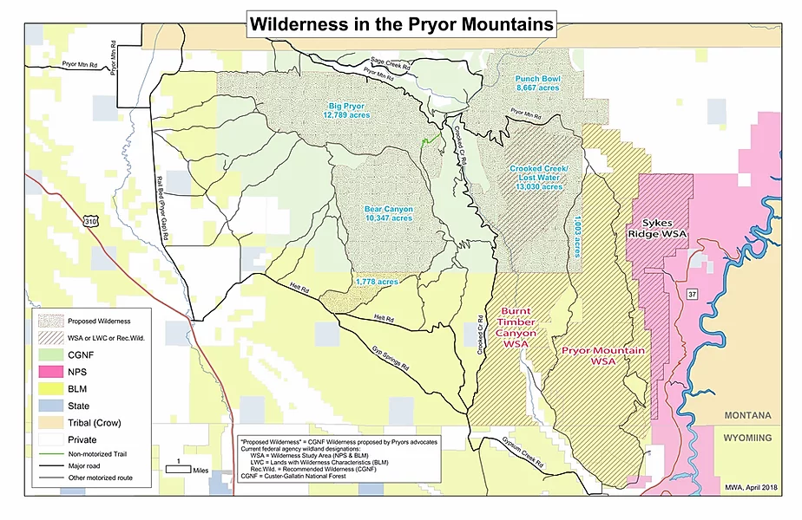
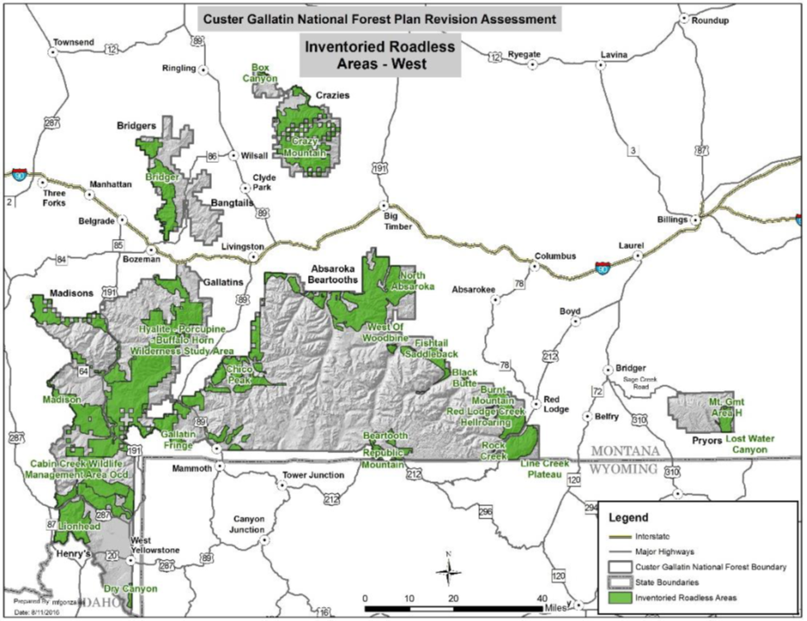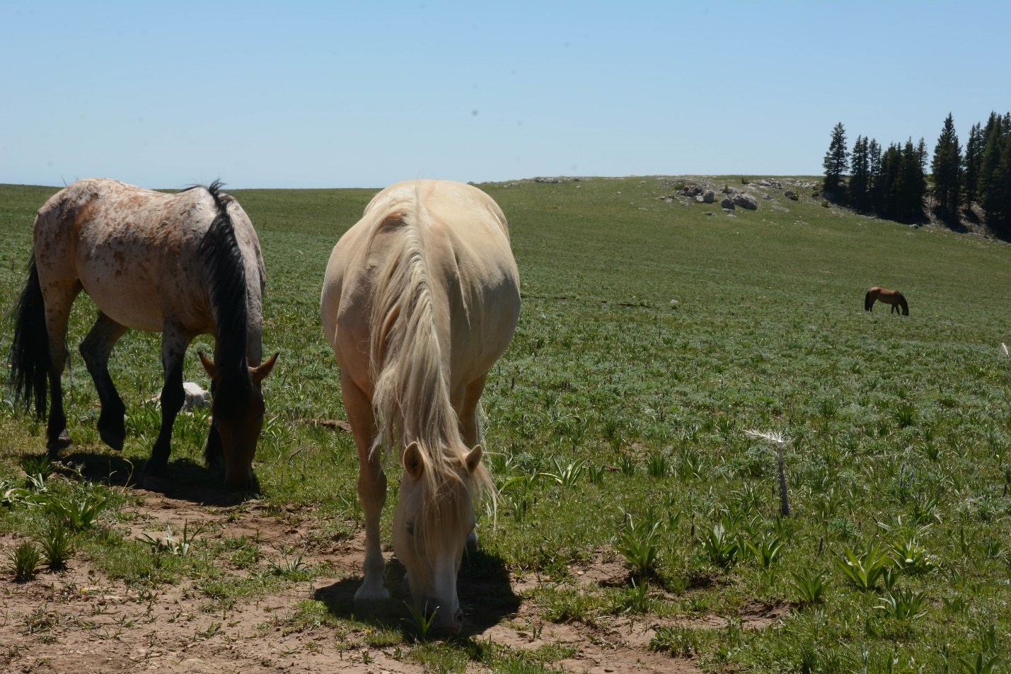
Pryor Mountains Feral Horses. Photo by George Wuerthner.

