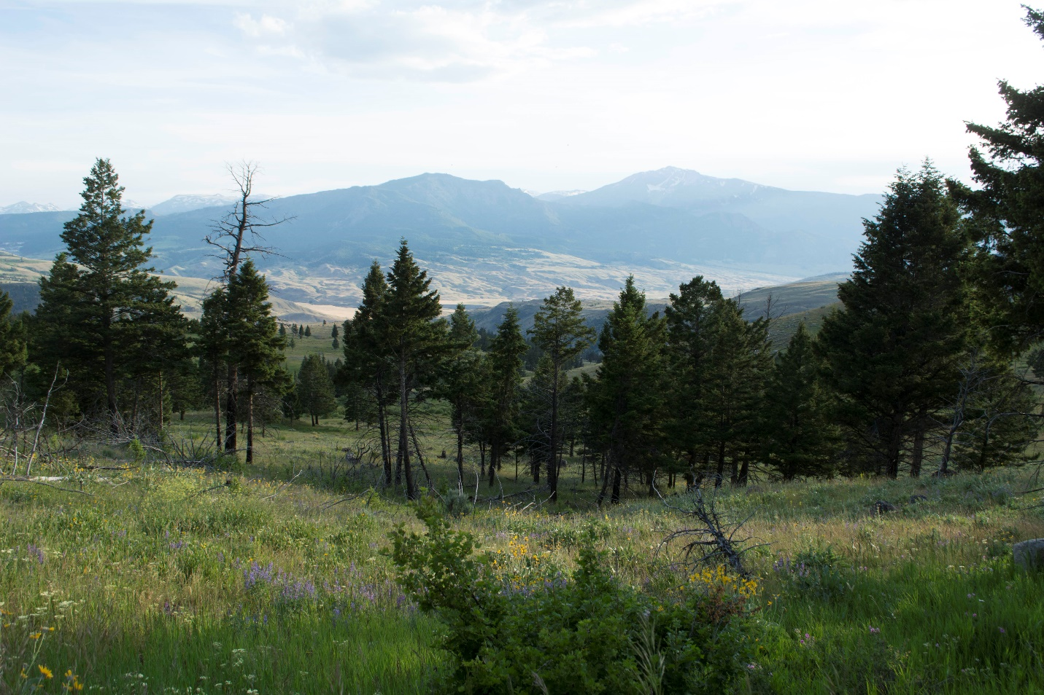
The Crevice Creek addition to AB Wilderness has aspen and meadow that provides excellent wildlife habitat. Photo by George Wuerthner.
NAME: CREVICE CREEK ADDITION TO AB WILDERNESS
SIZE: 406 Acres
ELEVATION:
LOCATION: South of Jardine immediately north of Yellowstone National Park.
FS POLYGON AB 50
ATTRIBUTES: The Crevice Creek roadless area is adjacent to the AB Wilderness and Yellowstone National Park. It includes Crevice Mountain. It borders on the Crevice Creek mining area. The area has scattered aspen and lots of sage covered hills. It is an important habitat for elk and other wildlife migrating out of Yellowstone National Park.
PLANT COMMUNITIES: 50% lodgepole pine and 10% whitebark pine with open meadows fringed by aspen.
WILDLIFE: Grizzly bear, black bear, elk, mule deer.
DRAINAGES WITHIN THE PROPOSED WILDERNESS: Crevice Creek.
