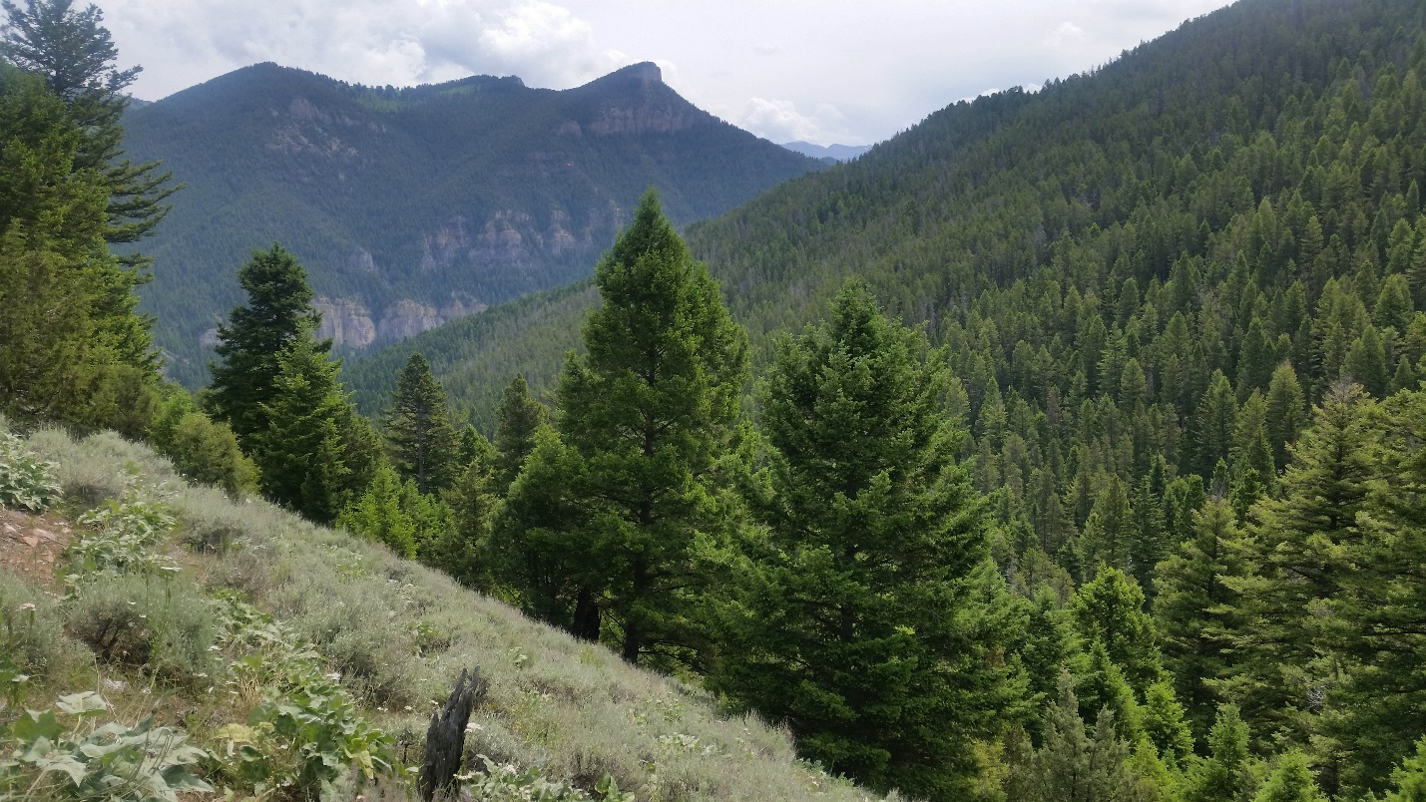
Looking down Moose Creek addition to Lee Metcalf Wilderness. Photo by George Wuerthner

NAME: SPAINISH PEAKS ADDITIONS TO LEE METCALF WILDERNESS
SIZE: 13,858 acres
ELEVATION:
FS POLYGON Madison 31, Madison 66, Madison 76
ATTRIBUTES: There are three potential additions to the Lee Metcalf Wilderness surrounding the Spanish Peaks unit of the wilderness. There are 10,235 acres on the eastern slope of the Spanish Peaks that includes Deer Creek, Hellroaring, Moose Creek, and South Fork Spanish Creek. The area is sandwiched between the Lee Metcalf Wilderness to the west and Gallatin Canyon to the east.
Another 2,951 acres that includes the south slope of Spanish Peaks above Big Sky. Finally, there is a small addition where the Spanish Creek Trailhead is located. There is a mountain bike trail in one corner.
PLANT COMMUNITIES: Most these areas are clothed in Douglas Fir, with small amounts of lodgepole pine.
WILDLIFE: Black bear, elk, moose, mule deer and bighorn sheep.
DRAINAGES IN PROPOSED WILDERNESS: Moose Creek, Hellroaring Creek, Deer Creek, Gallatin River,
