The Tongue River and Breaks. Photo by George Wuerthner.

NAME: TONGUE RIVER BREAKS

SIZE: 22,990 acres

ELEVATIONS: Minimum Elevation 3,139 ft. Maximum Elevation 4,185 ft.

FS POLYGON NUMBER: Ashland 22

LOCATION: Ashland District near Birney, Montana

ATTRIBUTES: The Tongue River Breaks/Poker Jim area is immediately east of the Tongue River. It consists of typical rolling terrain of the Northern Great Plains which drops abruptly towards the Tongue River creating badlands like “breaks”.

The proposed wilderness is somewhat unique on the Ashland landscape because it is largely unroaded. Although grazing is allowed there is a lower density of infrastructure than other allotments in the area as a result the area generally appears natural. The interior of this area is in a Semi-Primitive Non-motorized setting and with no trails or other recreation facilities and would provide the public with opportunities for unconfined and primitive recreation.

The Tongue River Breaks area is an especially important landscape to the Northern Cheyenne who collected plants, buried their ancestors, and left rock imagery, cairns and campsites.

PLANT COMMUNITIES: The general vegetation is open grasslands/sage with patches of ponderosa pine, especially on north-facing slopes.

WILDLIFE: The area supports elk, deer, and sage grouse, as well as other species typical of the northern Great Plains.

DRAINAGES WITHIN THE PROPOSED WILDERNESS: Birney Creek, East Fork Hanging Woman Creek,Lower Hanging Woman Creek, Poker Jim Creek.

SPECIAL ATTRIBUTES: Some 464 acres are within the Poker Jim Research Natural Area. It includes ponderosa pine forest, big sagebrush, silver sagebrush and wheatgrass.

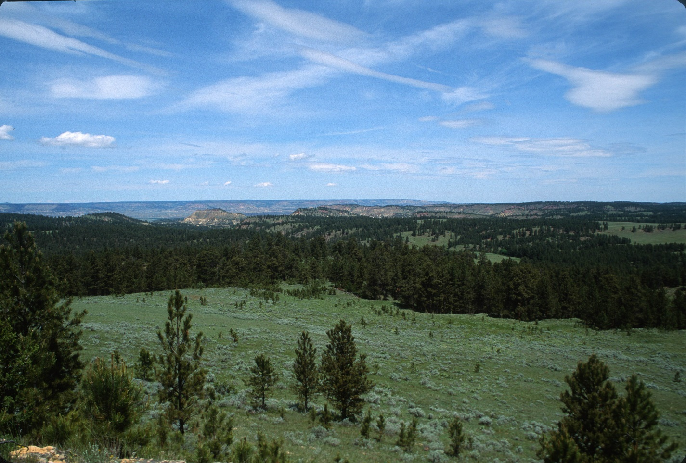

Tongue River Breaks from Poker Jim Lookout. Photo George Wuerthner

