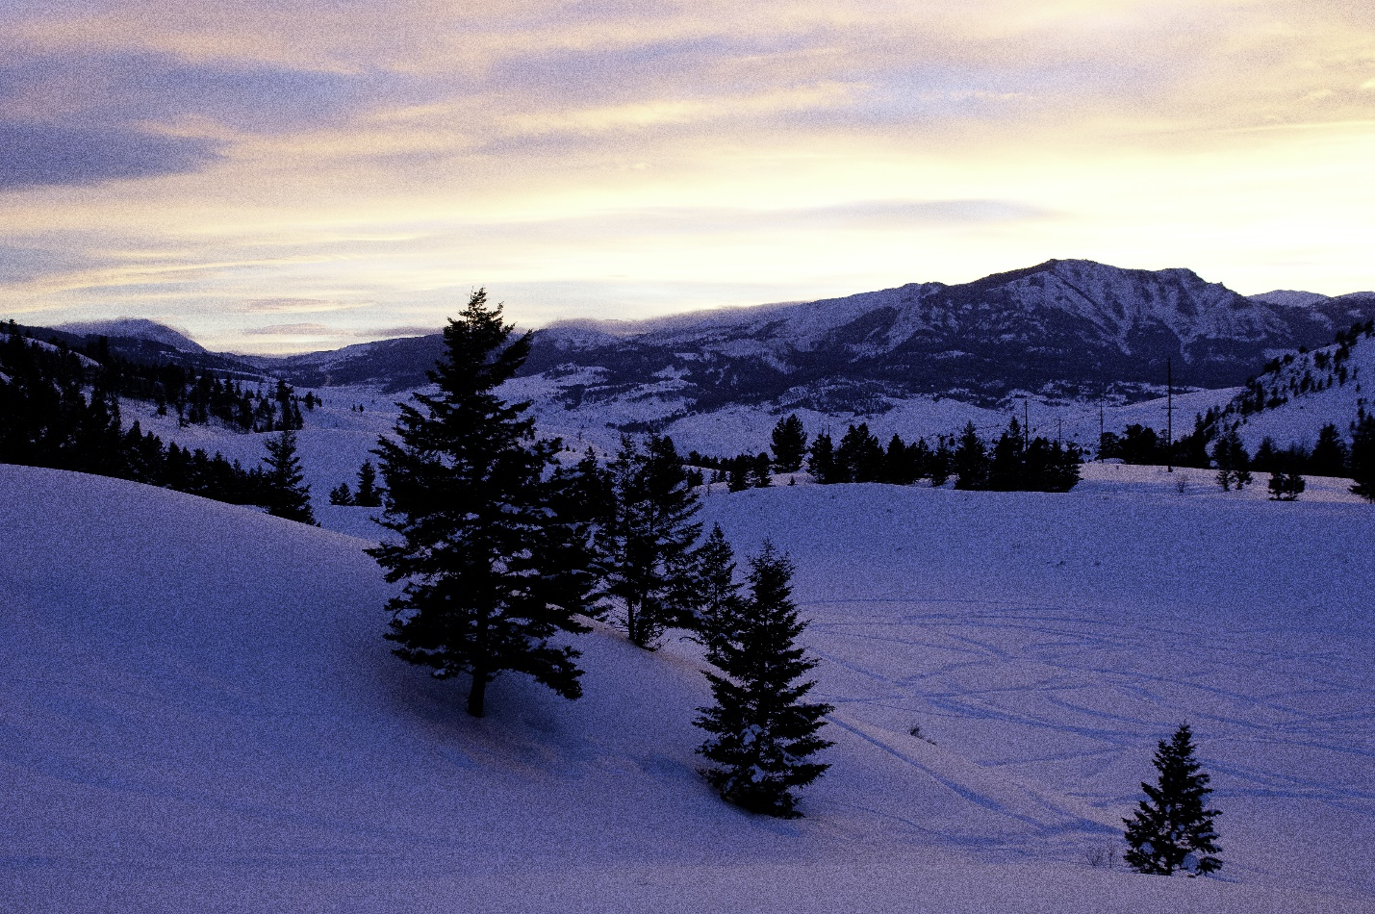
Looking from the Bear Creek addition to AB Wilderness towards Gallatin Range. Photo by George Wuerthner.
NAME: BEAR CREEK ADDITION TO THE ABSAROKA BEARTOOTH WILDERNESS
SIZE: 9,170 acres included.
ELEVATION: Minimum Elevation 6,147 ft. Maximum Elevation 9,400 ft.
LOCATION: Near Jardine, Montana just north of Yellowstone National Park
FS POLYGON AB 8
ATTRIBUTES: The Bear Creek addition to the Absaroka Beartooth Wilderness is bordered on two sides by the AB Wilderness and lies east of the Eagle Creek road and both north and south of the Jardine Road. The area is heavily used as a winter range by elk and bison, and is a popular area for the Jardine “hunt”. Both the Pine Creek and Palmer Creek trails are located in this area.
PLANT COMMUNITIES: 40% lodgepole pine, 25% Douglas fir, 15% shrubland and 10% dry grass
WILDLIFE: Grizzly bear, elk, bison, mule deer, and bighorn sheep. Yellowstone Cutthroat Trout known to occur within 9 miles of stream.
DRAINAGES WITHIN PROPOSED WILDERNESS: Bear Creek, Crevice Creek.
