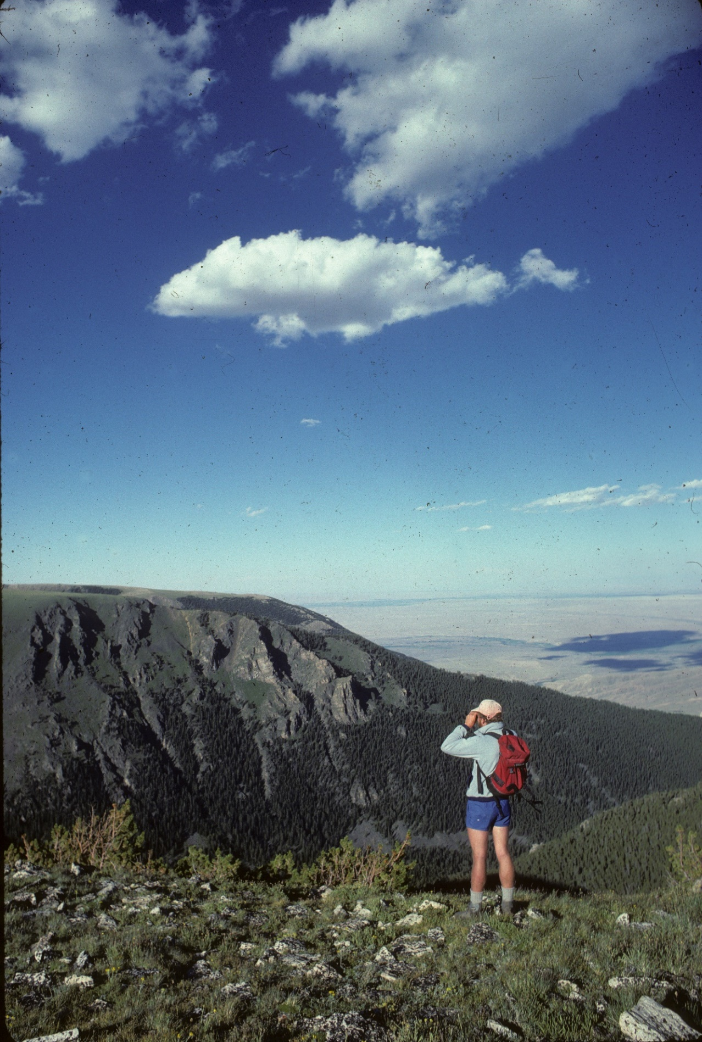
Hiker views elk herd on Line Creek Plateau. Photo by George Wuerthner.

NAME: LINE CREEK WILDERNESS
SIZE: 32,983 acres
LOCATION: Southeast of Red Lodge, Montana. The Beartooth Highway forms the western border.
ELEVATION: Minimum Elevation 5,943 ft. Maximum Elevation 10,201 ft.
FS POLYGON: AB 6
ATTRIBUTES: The Line Creek Plateau Wilderness is a high alpine area with steep limestone cliffs dropping down to dry basins on the east side of the Beartooth Mountains. The area contains the 16,127-acre Line Creek Research Natural Area which consists of extensive areas of alpine tundra vegetation, a cirque basin with alpine lakes and ponds, as well as, many unique plant species. Nine alpine, seven coniferous, and one shrub land vegetation types fulfill requirements for the Northern Region RNA network.
The Line Creek Plateau is immediately east of the Beartooth Highway and close to the existing Absaroka Beartooth Wilderness.
Additional contiguous roadless lands lie in the Deep Lake Roadless Area in Wyoming, which forms a southern extension of the Beartooth Plateau lie in Wyoming on the Shoshone National Forest.
PLANT COMMUNITIES: 6,451 acres classified as alpine ecosystems with 30% dry grass, 25% lodgepole pine, 20% whitebark pine, 10% transitional forest, and 5% Douglas fir. Approximately 1,678 acres burned in 1991 and another 3,651 acres burned in 2011.
WILDLIFE: Mountain goats, elk, mule deer, black bear. Yellowstone Cutthroat Trout known to occur within 4 miles of stream.
DRAINAGES WITHIN PROPOSAL: Line Creek, Rock Creek, and Snow Creek.
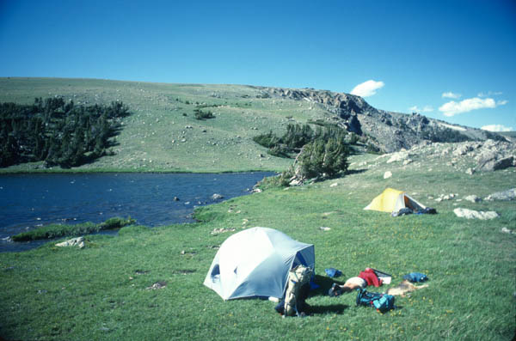
Camping by Line Lake. Photo by George Wuerthner
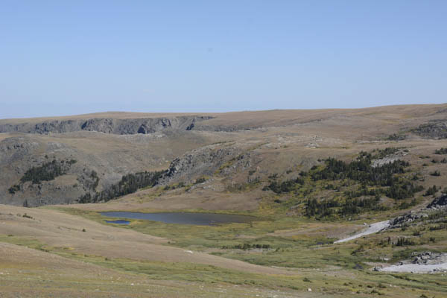
Alpine tundra on the Line Creek Plateau. Photo by George Wuerthner

