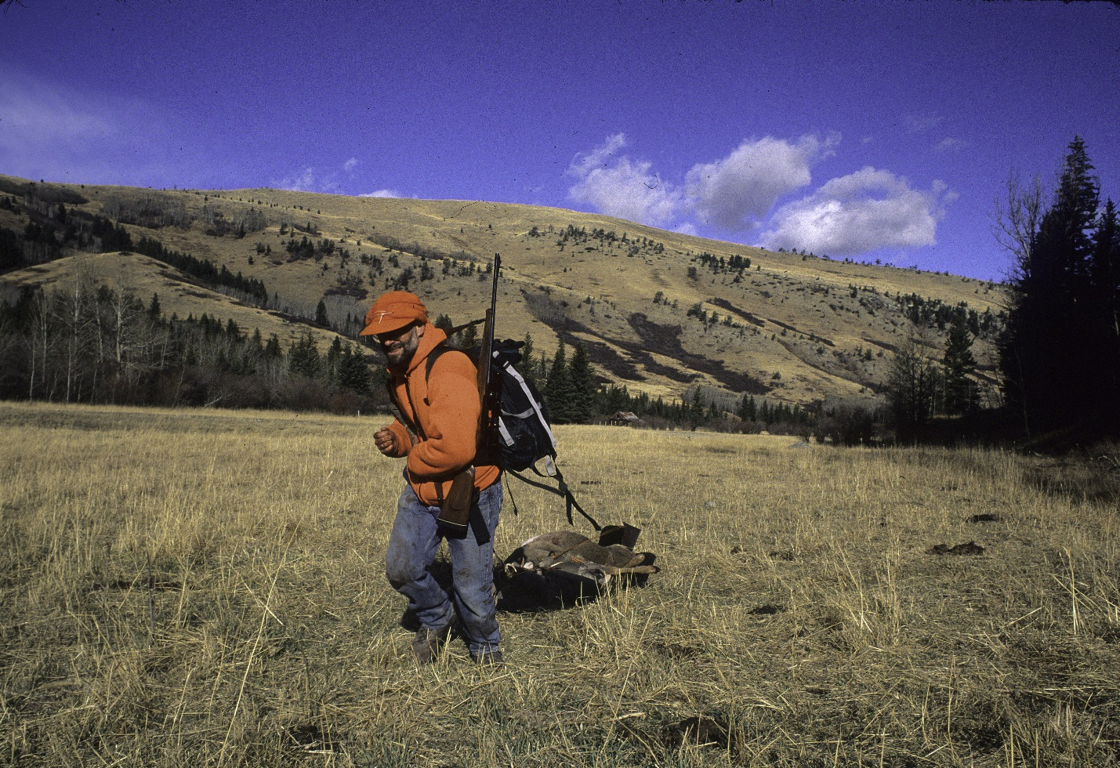
A hunter drags a deer out of the West Boulder addition to the AB Wilderness. Photo by George Wuerthner.
NAME: WEST BOULDER ADDITION TO AB WILDERNESS
SIZE: 1,109 acres.
ELEVATIONS: Minimum Elevation 5,566 ft. Maximum Elevation 6,734 ft.
LOCATION: This area is southeast of Livingston and directly east of the West Boulder campground.
FS POLYGON: AB 77
ATTRIBUTES: The West Boulder addition to the AB Wilderness is a small area immediately adjacent to the Absaroka-Beartooth Wilderness. This area is very natural in appearance, although it has burned there is terrific aspen regeneration occurring.
PLANT COMMUNITIES: Aspen, 40% Douglas fir, 40% transitional forest with 10% unclassified.
WILDLIFE: Elk, whitetail deer, mule deer, black bear.
DRAINAGES WTIHIN THE PROPOSED WILDERNESS: West Boulder River.

